Terraform Remote State management:

Team colloabration:

Local Changes are not always good

Currently we have been working with terraform code locally.

Terraform Security:

Supported backend types

Terraform supports various types of remote backends which can be used to store data.

As of now, we were storing state data in local and git reporsitory.

Depending on remote backends which is being used,there can be various features,

Standard Backend Type: State storage and Locking

Enhanced Backend Type: All features of Standard + Remote Management.

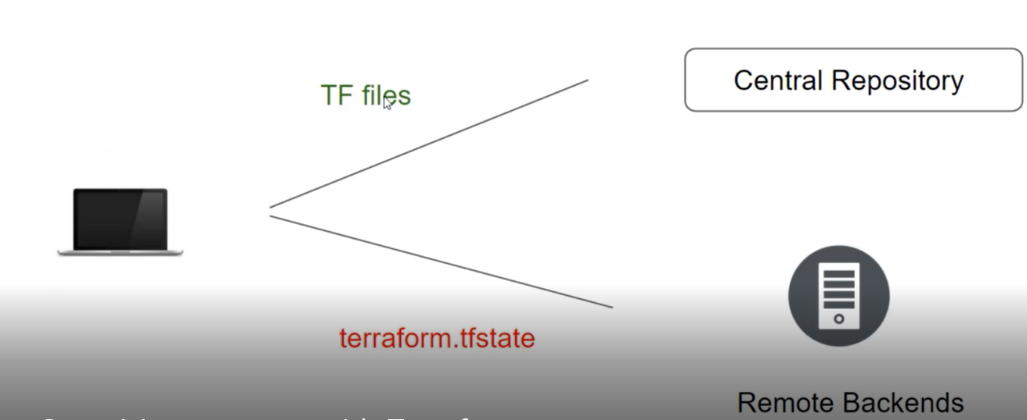

Terraform State Locking:

Whenever you are performing write operation, terraform would lock the state file.

This is very important as otherwise during your ongoing terraform apply operations , if others also try for the same, it would corrupt you state file.

Example:

Person A is terminating the RDA resource which has associated rds.tf state file

Person B has now tried resizing the same rds resource at same time.

Terraform State Modification:

As your terraform usage becomes more advanced,there are some cases where you may need to modify the terraform state.

It is important to never modify the state file directly, Instead make use of terraform state command.

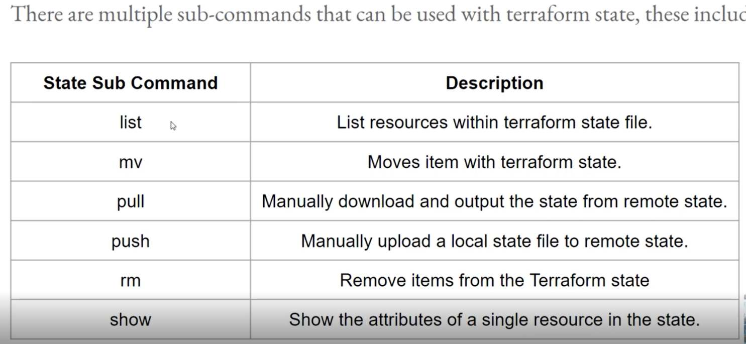

Sub command list: The terraform state list command is used to list resources within a terraform state.

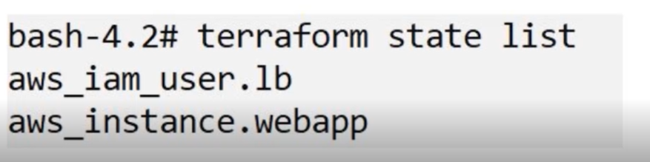

#terraform state list

Sub command –Move:

The terraform state mv command is used to move items in a terraform state.

This command is used in many cases in which you want to rename an existing resource without destroying and recreating it.

Due to the destructive nature of this command, this command will output a backup copy of the state prior to saving any changes

Syntax:

Terraform state mv [options] Source Destination

#terraform state mv aws_instance.myec2 aws_insatnce.webapp

#terraform plan

Sub command-pull

The terraform state pull command is used to manually download and output the state from remote state.

This is useful for reading values out of state(potentially pairing this command with something like jq).

#terraform state pull -🡪 this is pulling s3 to local tf.state file

Sub command –Push:

The terraform state push command is used to manually upload a local state file to remote state.

This command should rarely be used.

Sub command –Remove:

The terraform state rm command is used to remove items from the terrform state.

Items removed from the terraform state are not physically destroyed.

Items removed from the terraform state are only no longer maged by Terrafrom.

Ex: if you remove an AWS instance from the state , the AWS instance will continue runnin, but terraform plan will no longer see that instance.

#terraform state list

#terraform state rm aws_instance.myec2

Sub command – show:

The terraform state show command is used to show the attributes of a single resource in the terraform state.

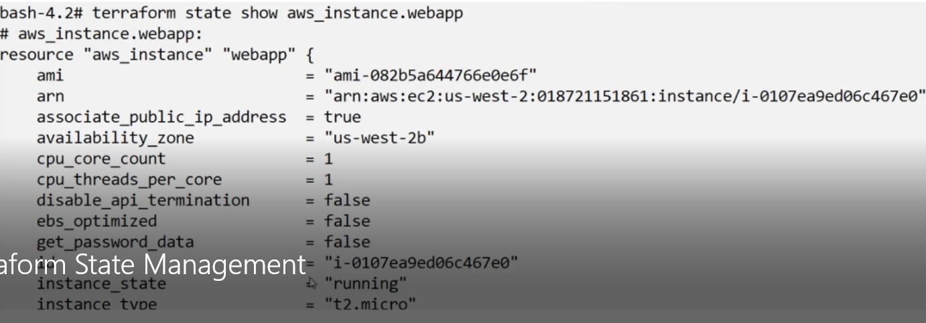

Terraform Import:

It might happen that there is a resource which is already created manually.

In such case, any chane you want to make to that resource ,must be done manually.

#terraform import aws_insatnce.myec2 i-041228374693